

**B Tech. Fall Semester 2022-2023**

**CSE 3002 INTERNET & WEB PROGRAMMING**

**J COMPONENT**

**Under the guidance of,**

**Prof Maheshwari S**

**TOPIC – COMPLAINT REGISTRATION PORTAL**

**TEAM MEMBERS –**

**1. Parth Tiwari (20BCE1653)**

**2. Dhruvi Ochani (20BCE1882)**

**3. Aryan Bhardwaj (20BCE1908)**

**4. Shah Siddh Tejaskumar (20BCE1937)**

**ABSTRACT**

Since a lot of students have been facing constant difficulties and complaints regarding hostels or mess or Wi-Fi, it has been troublesome experience and not very convenient for both the students and the staff. There has been a l ack of understanding, communication and genuine interest from both sides which leads to certain difficulties. As a result of this, we have come up with an Online Registration Complaint Portal which attempts to reduce these difficulties to the maximum extent and make dealing with complaints a little easier and comprehensive.

The project Complaint Registration Portal is a web-based application that allows the admin to handle all the lodged complaints, manage them in flexible, convenient and an efficient manner. Since the admin is a very busy person and does not have the time to sit and manage the entire activities manually on paper, this application gives him/her the power and flexibility to manage the entire system from a single online system without facing any difficulties at all. The Online Complaint Registration Portal provides the user to register itself and then login safely to access the system and raise issues which he/she faced which can be concerned with any activity. The system hence provides an online way of solving the problems faced by the user in a better and more effective way without having the need to register for their complaints manually by writing in registers and thus maintaining bulk of records.

**Keywords – Complaint, Registration, Portal, Online, Web-Application, records, admin, users, flexibility, efficient, Wi-fi, hostel, mess**

**INTRODUCTION**

The Complaint Registration Portal is a web-based application, and it is designed to keep track of complaints registered by the users of the system. The admin has control over all the activities of the system. The system is designed for a user of a college to lodge any complaint regarding any specific category. The admin can monitor all the user log activities and can also view all the complaints lodged by the users of the system. The admin can then choose to take necessary action against the complaint and the file the subsequent report. The system also allows the user to view the status of their complaint.

The objective of the Complaint Registration Portal is to simplify the life of a student in the college, hostel, and even online education. The system will be able to handle many services to take care of all users in a prompt manner. As a solution to the large amount of file handling happening at the college, this software will be used to overcome those drawbacks. Safety, easiness of using and most importantly the efficiency of lodging complaint and report generation are some of the benefits that this system is going to present. The system is user appropriate, easy to use, provide easy recovery of errors and have an overall high satisfaction.

**LITERATURE SURVEY**

**PAPER 1**

**Paper Title –** Decision Support System: UTHM Pagoh Residential College Online Registration and Complaint

**Authors** –Hazwani Rahmat, Muhmad Haiqal Omar, Nurin Afrina Saad

**Date of Publication** – November 2020

This research paper attempts to solve students’ residential issues and difficulties. According to a preliminary conversation with the residential college administration, the residential college management now assigns rooms to students once they register using a manual business process, regardless of their ethnicity or religion. However, most Malaysians, particularly UTHM students, are Muslims. It is essential to provide residential housing with suitable room assignments since it is possible for students to cook in the college or bring outside food that is not halal. With the use of a decision-making technique, grievances, and online access to information from residential colleges, by this project and paper the authors attempt to assist students in reserving their rooms.

**PAPER 2**

# Paper Title – Analysing and Implementing a System for Reporting, Follow Up and Resolving of Complaints

# Authors – Angham Al Abbas, Khadeeja Alzayer, Mutasem Alsmadi

**Date of Publication** – July 2019

This research paper aims to make complaints easier to be reported, coordinated, monitored, tracked and resolved, and to provide governments with effective tool to keep records of complaint data, to use them for identifying problem areas and to improve services. The base of the problem statement remains the same, creating a platform to store and resolve complaints easily.

**PAPER 3**

# Paper Title – Smart Complaint Management System

# Authors – Pattamaporn Kormpho, Panida Liawsomboon, Narut Phongoen, Siripen Pongpaichet

**Date of Publication** – July 2018

SCMS was developed to enhance the current complaint management system by using the mobile application and web application. Therefore, SCMS was able to provide several channels for filing the complaint, which enables users to send the complaint easier, and also provides the channel for progress tracking by using the mobile application. Moreover, SCMS was capable of classifying the complaint and directly sending it to the appropriate responsible department, therefore, the system could reduce the cost of hiring the staff and time of the operation. In addition, SCMS could decrease the duplicate complaints by suggesting similar complaints to users. Furthermore, SCMS allows the staff to manage the complaint through the web application instead of done manually on the paper form. Finally, the system generates the data visualization for the summary of complaint data.

**METHODOLOGY**

* The existing system for resolving student’s queries and difficulties is not viable and convenient on a long run.
* Not only that, but it is also a lot slower and requires the use of a file-based system where-in the users have to write their complaints in just about 2-3 lines, our system immensely improves on this.
* Moreover, it is quite difficult to keep a track record of all the past complaints and resolve them efficiently using such an outdated file-based system.
* This system is not at all user friendly.
* The platform that we are willing to design can handle the complaints details without any difficulty & with minimal effort. As the work is done manually before, it will be very time consuming & require large efforts to maintain the files. By computerizing the system these files can be handled with a small effort & in less time.
* The chances of duplicity of complaints are negligible. The complaint report can be generated easily by getting the information without any problem from all the related files. The platform will be designed in a very interactive way to make it user friendly & easy to use.

**FUNCTIONAL REQUIREMENTS OF THE SYSTEM**

* The system creates an account or the user after the registration is completely done, and the user has the facility to change login credentials anytime he wants.
* The user can select the complaint category and subcategories along with the type of the complain the user wants to register.
* The user can select the block, nature of the complaint by giving a brief description about it. If necessary, the application provides the user an option to select a file describing his/her complain.
* The user also has an access to his complaint history where he can view all his previous complaints and check their status. Also, if required the user has an option to view the entire complaint details of any of his former complaints.
* This system allows the admin to process all the complaints registered by different users and have a look at the number of complaints that haven’t been processed yet, the number pending complaints, and the number of complaints that have been completely resolved and closed.
* The application provides the admin an option to add complaint categories and sub- categories that are dependent on various issues faced by the users. The admin can also give a description about the added categories.
* The system also provides the functionality where the admin can add different academic blocks in the application. The admin can add a subcategory based on the different categories of complaint which would help the admin to generalize the complaints.
* The application provides the admin an option to manage the user activities to view their login and logout time and the user details. The system shows the user login status to the admin, successful if the user has entered correct credentials, else shows failed.
* When the admin enters the correct credentials, he should get complete access to the entire Complaint Registration Portal.

**NON-FUNCTIONAL REQUIREMENTS OF THE SYSTEM**

* The users should be able to safely sign up and login to the Complaint Registration Portal without any data breach. Data security of users is one of the system’s main priorities.
* The system should provide the admin complete access of the application and enable him to keep a track of users’ complaints and maintain records.
* The admin ensures that the complaints registered by the user remain confidential and are resolved within time. Also, the admin owns up to the task of making sure that all the complaints are carefully looked upon and are resolved comprehensively.
* All the records and documents of each user should be linked together for easy access and better efficiency.
* The database and application should be available to the users and admin 24x7 without any inconvenience.
* The system should provide an option to update the credentials or records of the users if required.
* The application should be easy to use, time and cost efficient, properly designed and make life easier for all its users. The flow of information in the system should not be broken.

**RESULTS AND DISCUSSION**

**1. USE CASE DIAGRAM**

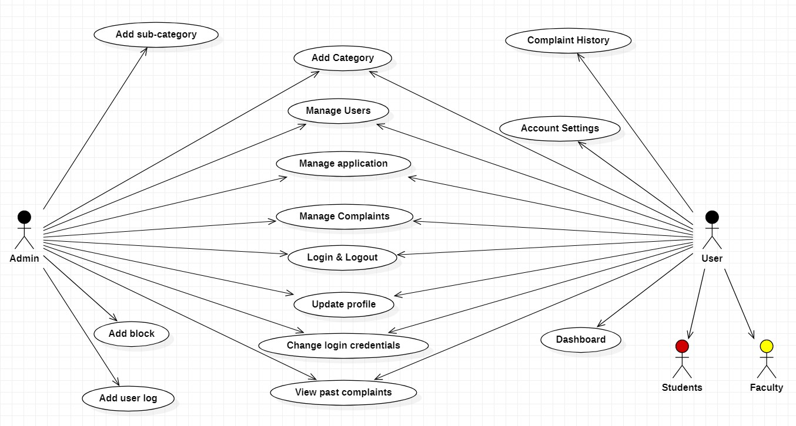

* This use case diagram justifies the entire functioning of the web application and what are the features available to both the users and admin and how they can make use of them.
* It depicts all the functionalities that are common to both the users (students, staff, or faculty) and admin and the ones which are specific to either of them.

**2. SEQUENCE DIAGRAM**

For admin –

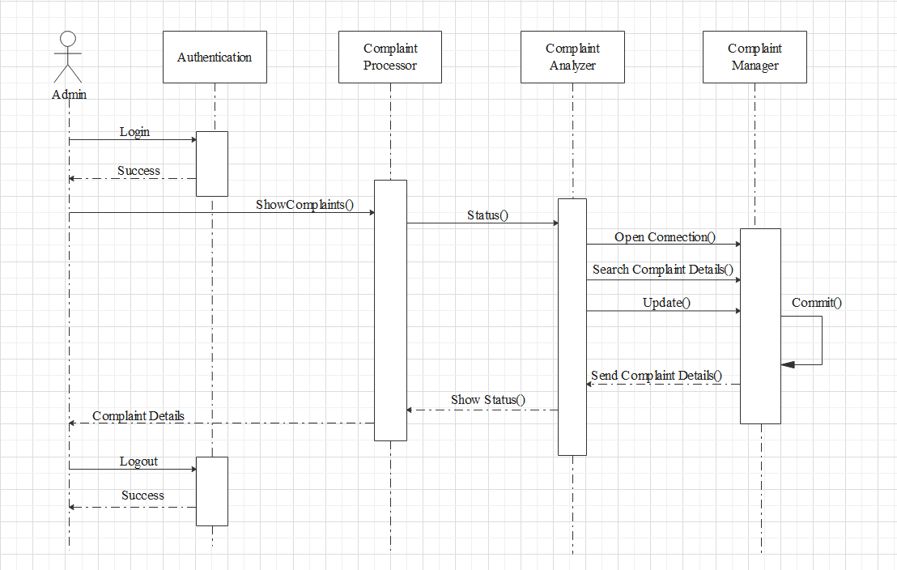For users –

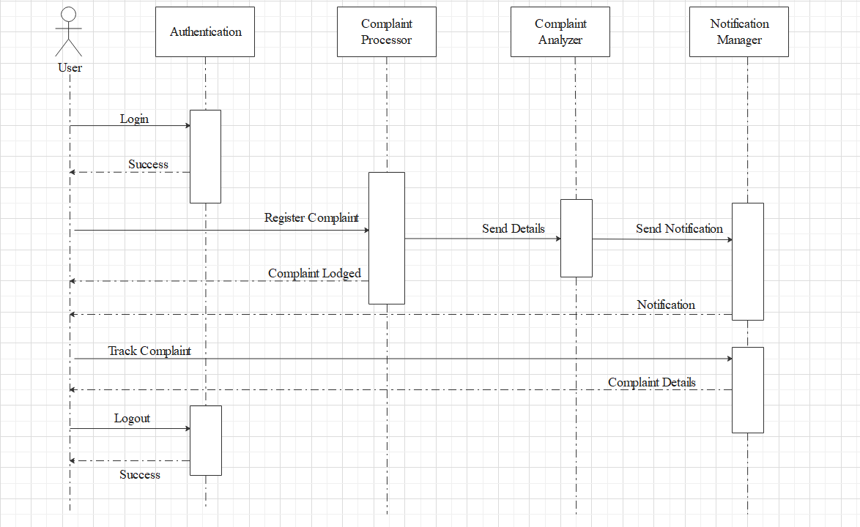

**3. ARCHITECTURE**

**3.1 Data Centric Architecture**

Our system relies heavily on its database, both the user relevant complaint data and the data admin gives it. The database-centric architecture offers:

* A standard relational database management system. This means the data will be stored away from the client-side application.
* Dynamic table-driven logic. We need to update the tables every time complaint status change.
* Stored procedures running on database servers to analyse our data.
* A shared database for communication between parallel processes.

**3.2 Tier Based Architecture**

To make the model equipped for handling complaint, the researchers have divided the proposed model into 3-tiers:

Storage – tier: It includes information pertaining to those who use the system, their profiles, citizens information available resources in addition to social association profiles.

Business – tier: It is composed of the system key part that includes complaint handling and feedback components.

Presentation - tier It comprises web-based user interface.

**4. SUBSYSTEMS AND HARDWARE**

Our software employs the use of a client/server system. The client–server model of computing is a dispersed application structure that divides tasks between the provider of a resource or service, called the server, and an entity making a request, called the client. This establishment can be made with a network connection between host (the server) and client, or it is possible for this relationship to exist on the same system, sharing hardware.

A web browser will be used to request the various data from our server, as well as retrieve stock information and updates that can be sent and retrieved via communication with that server. The GUI, which will run on the web browser, will be executed client side while the process itself is handled by the server’s web service. The web service will ensure proper transmission of user data between the client and the server.

**5. GRAPHICAL USER INTERFACE (SCREENSHOTS)**

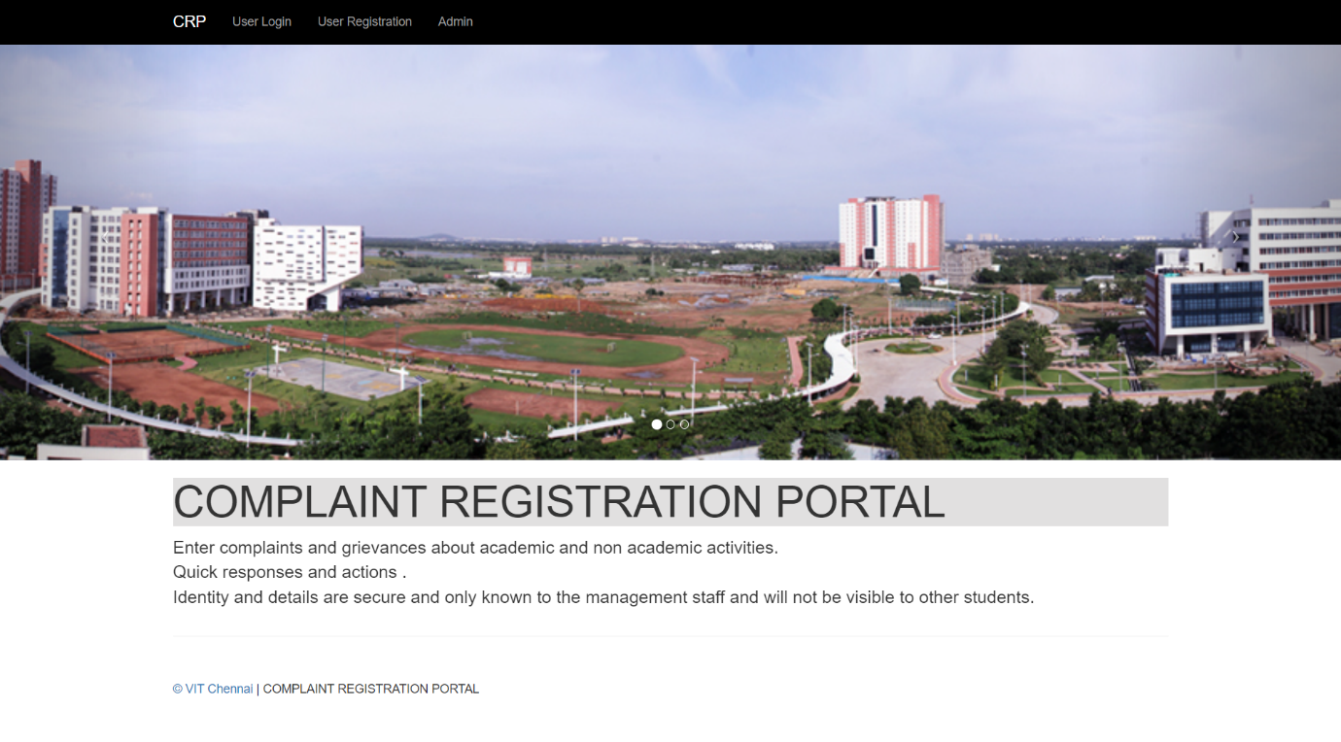

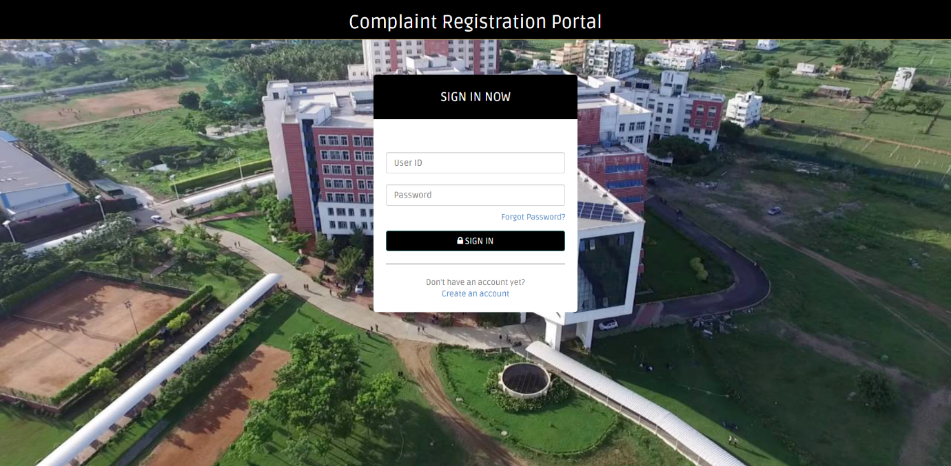

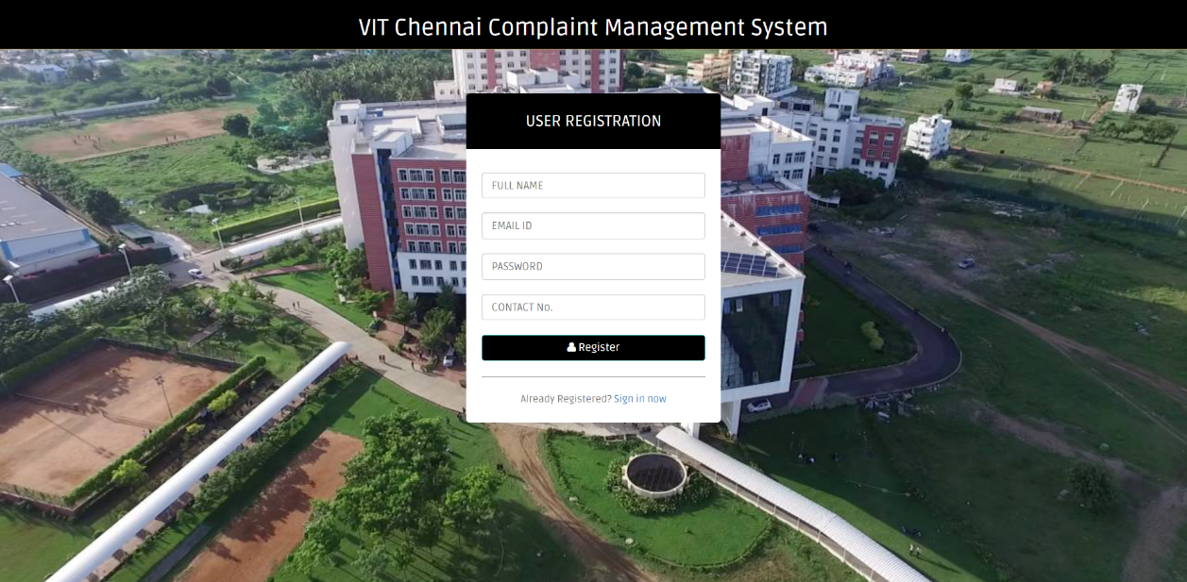

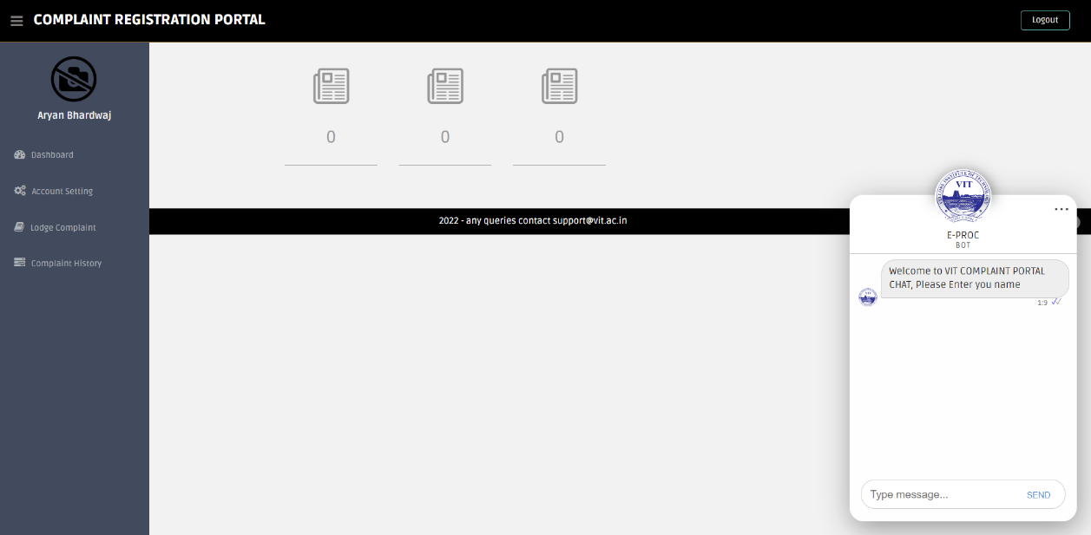

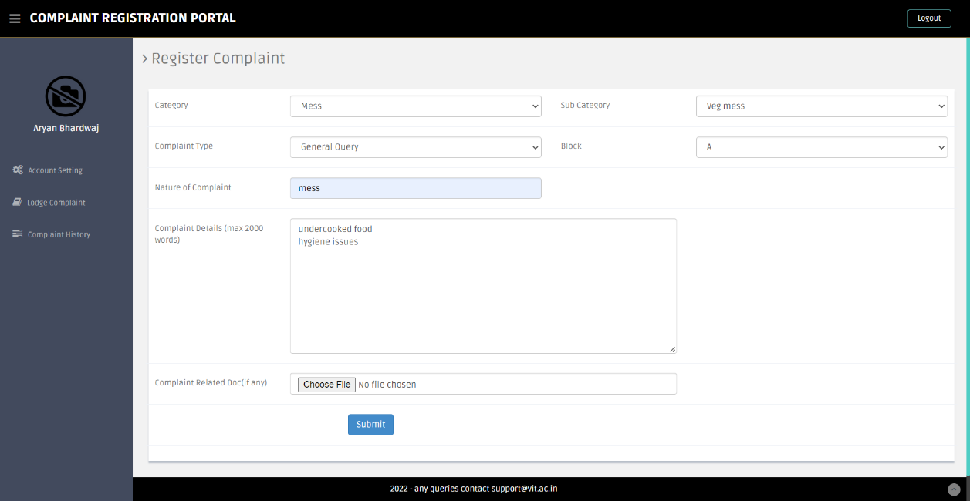

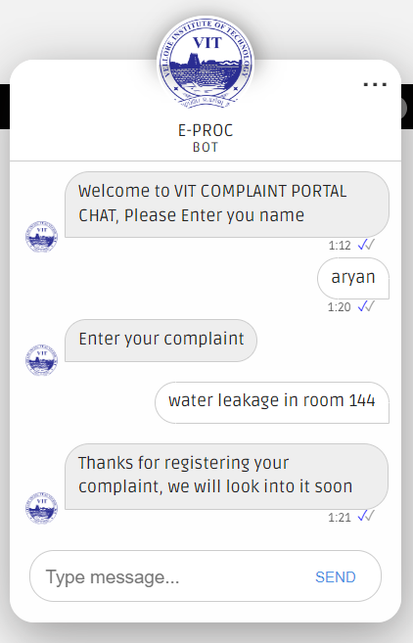

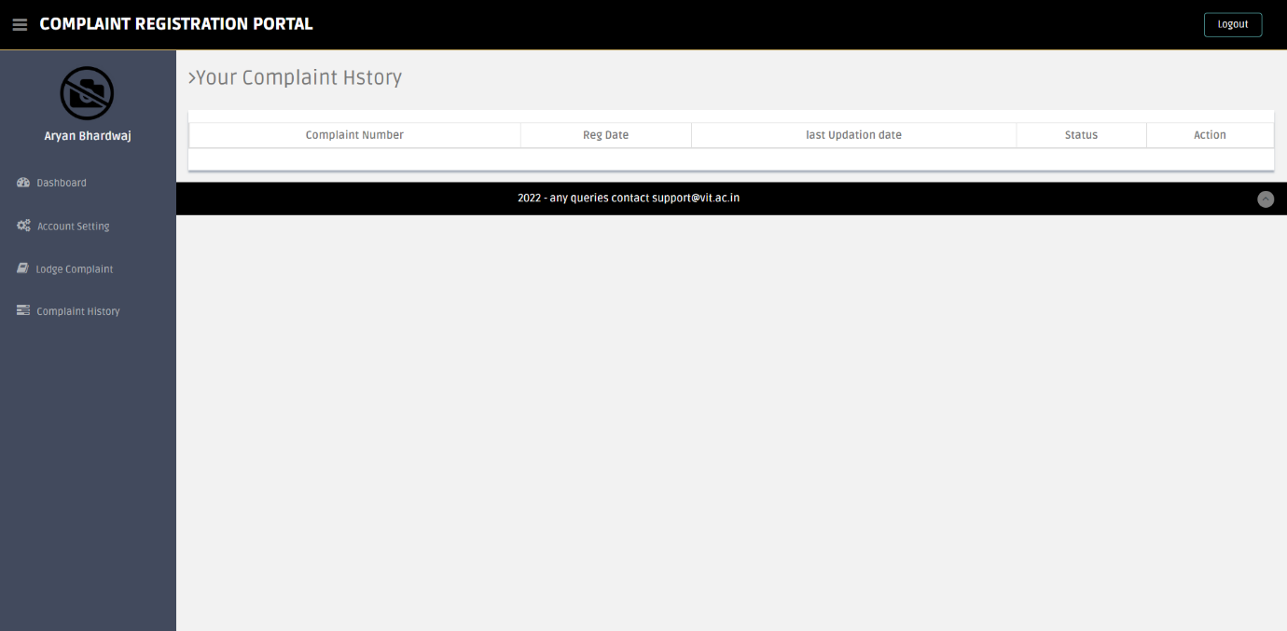

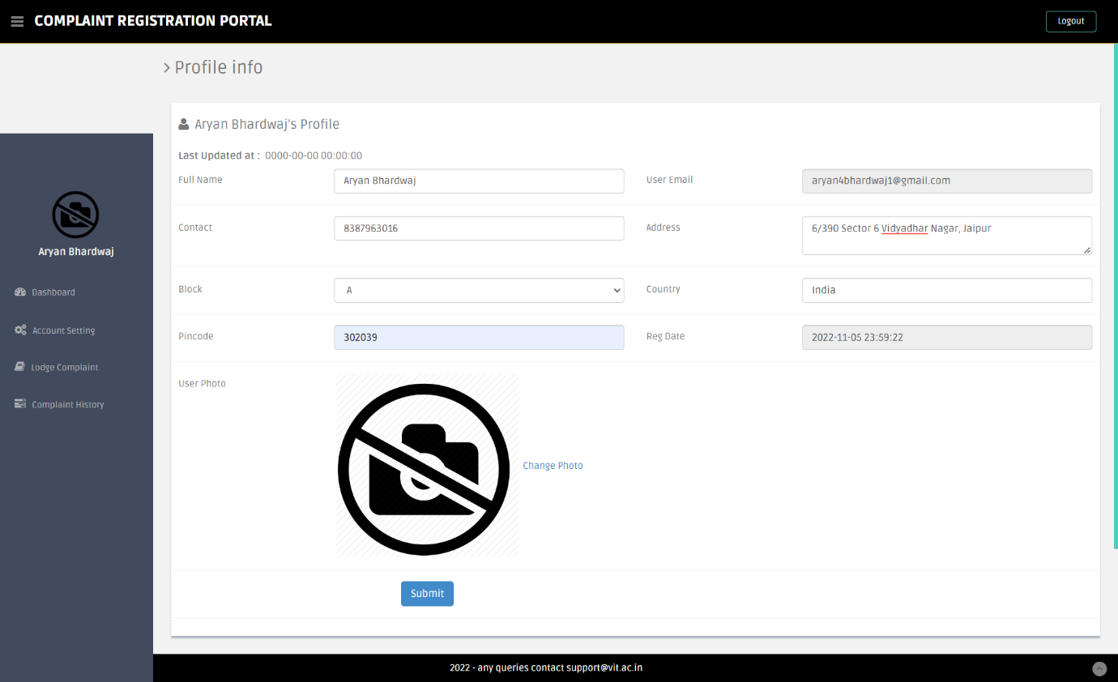

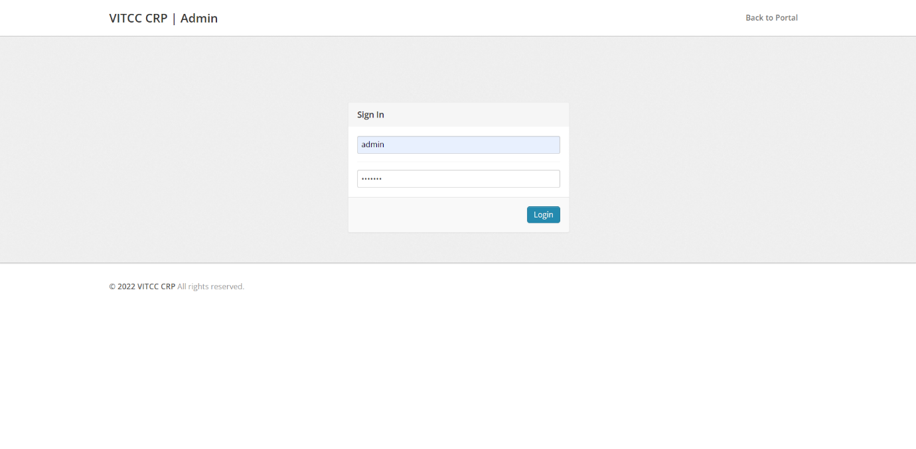

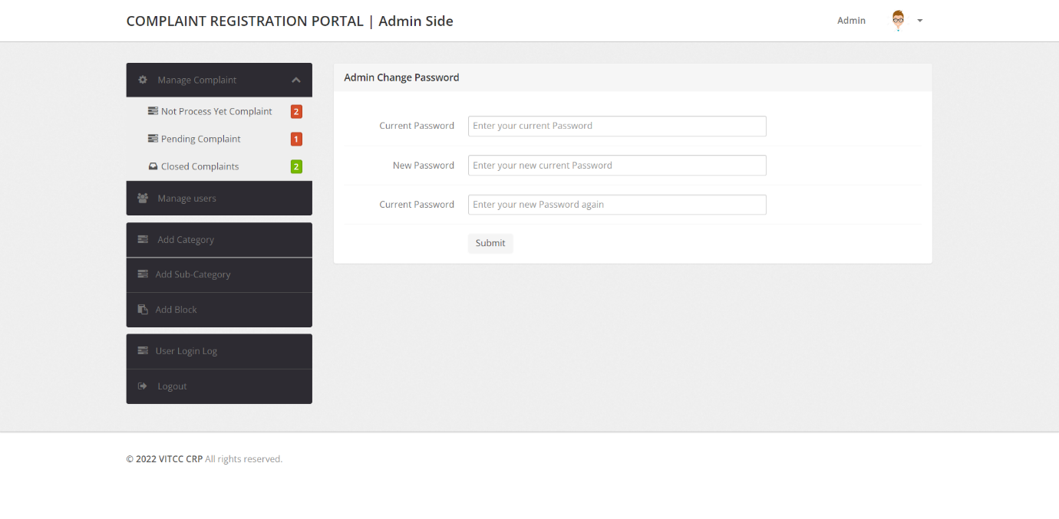

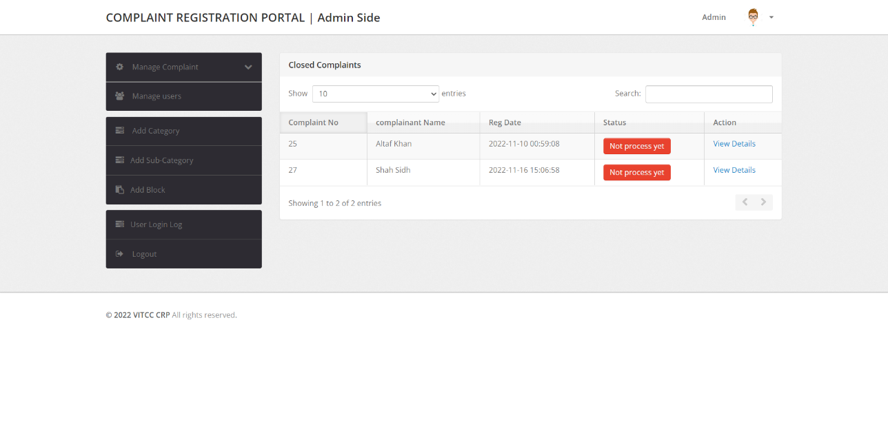

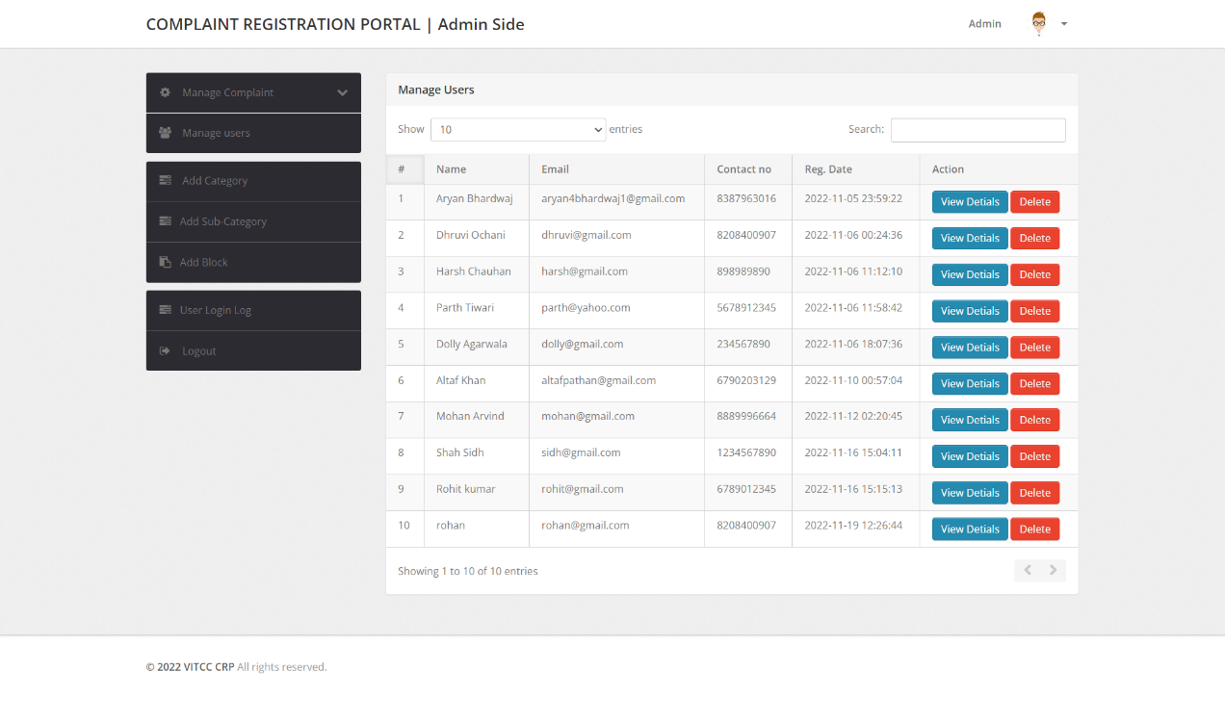

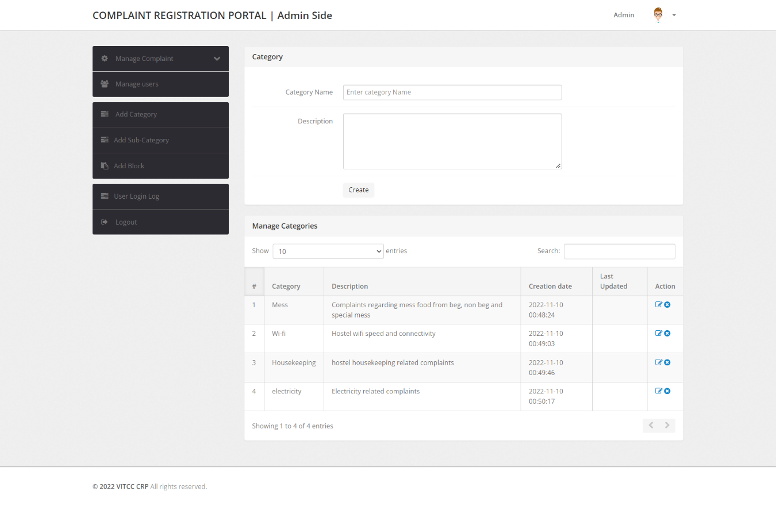

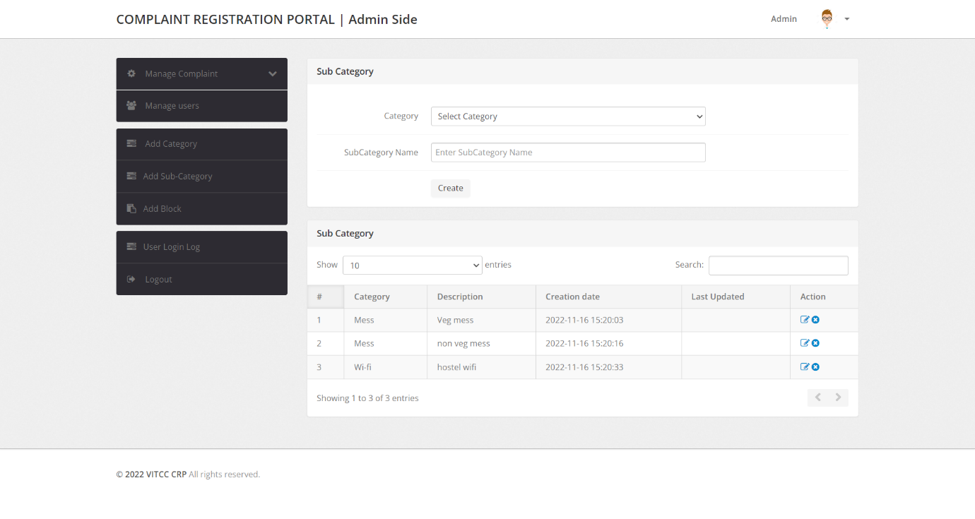

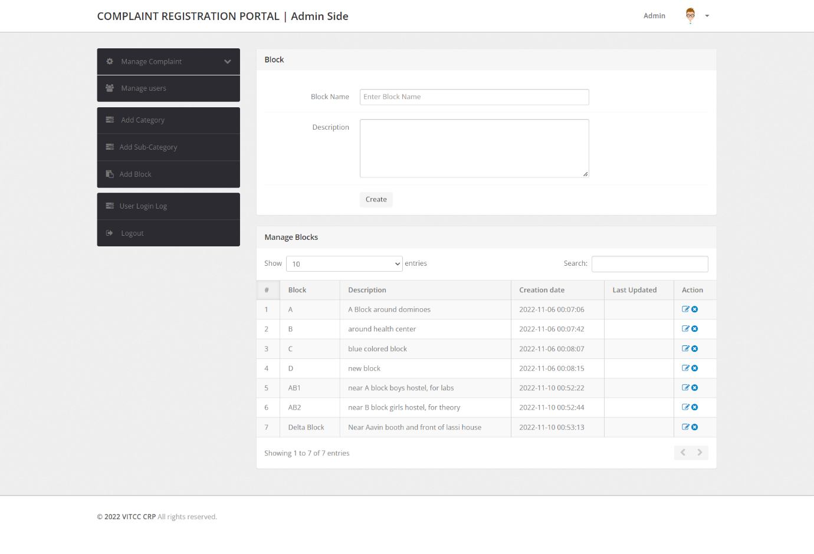

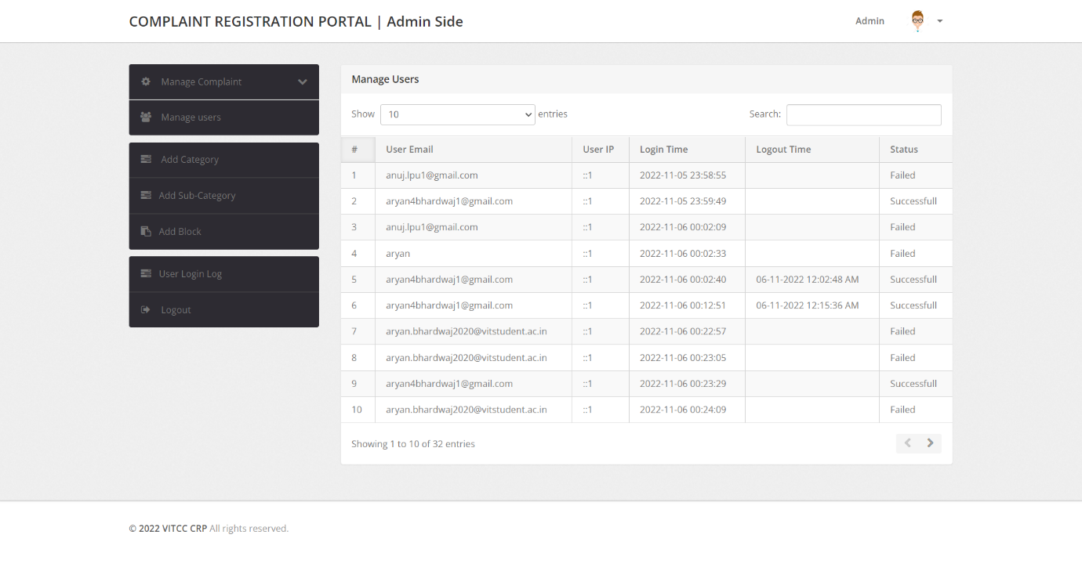

**CONCLUSION**

We believe our Online Complaint Registration platform will be of massive help for all college students, faculties, staff, admin and the entire management. It is very user friendly, time & cost efficient and a solid replacement for existing systems which generally include registering complaints via files.

The application has everything which makes life easier for everyone associated with the college. One does not have to be hesitant to register complaints on this platform as all the details about its users are kept confidential along with their complaints. The platform makes it easy for students especially learning via Online mode of education since it takes a toll to study and causes a lot of issues and difficulties.

Our Complaint Registration Portal if properly implemented by the college will be of great use. Easy to use, great user interface, time saving & efficient with utmost security of data and 24x7 availability makes it a very handy tool.

This package will provide accuracy, efficiency, speed, and easiness to the end user. Since the system is verified with valid as well as invalid data and is run with an insight into the necessary modifications that may be required in the future, it can be maintained successfully without much effort.

**REFERENCES**

* Ian Sommerville Software Engineering 8th edition 2008
* Michael J. O'Fallon, Denney G. Rutherford, Hotel Management and Operations illustrated edition, John Wiley & Sons, 2001
* <http://www.high-level-software.com/features/>
* <https://hillside.net/plop/plop99/proceedings/Fernandez2/reservAnalysisPattern3.PDF>
* <https://pgportal.gov.in/>
* <https://www.softwareworld.co/best-complaint-management-software/>
* <https://services.india.gov.in/service/detail/public-grievances-portal-pg-portal>